Cov Neeg Xaugj* thiab cov tswv tsev

tau txais DAWB Cov Tsev Hluav Taws Xob Hauv Tsev Hluav Taws Xob mus saib qhov uas lawv yuav nruab:

* LEDs • Qhov rooj huab cua
* Cov txheej txheem ntsuas huab cua • Thiab lwm yam

THIAB

Tau txais DAWB $20 Kev Lag LuamPhaw Khoom Plig rau ntawm kojlub khw tshav puam muag zaub

Teem sij hawm mus saib dawb ntawm koj hnub no hu rau 651-328-6220

Txhuas tus yuav tsum muaj kev nkag tau rau cov zaub mov tshiab, noj qab nyob zoo, zaub mov hauv zej zog. Cov Khw Muaj Khoom Noj yuav pab cov neeg muag zaub mov SNAP rub lawv cov nyiaj ntawm lub khw los ntawm kev ua cov zaub mov muaj txiaj ntsig zoo. Koj tuaj yeem yuav SNAP cov khoom noj uas tsim nyob tau muaj nyob ntawm lub khw yuav zaub mov.

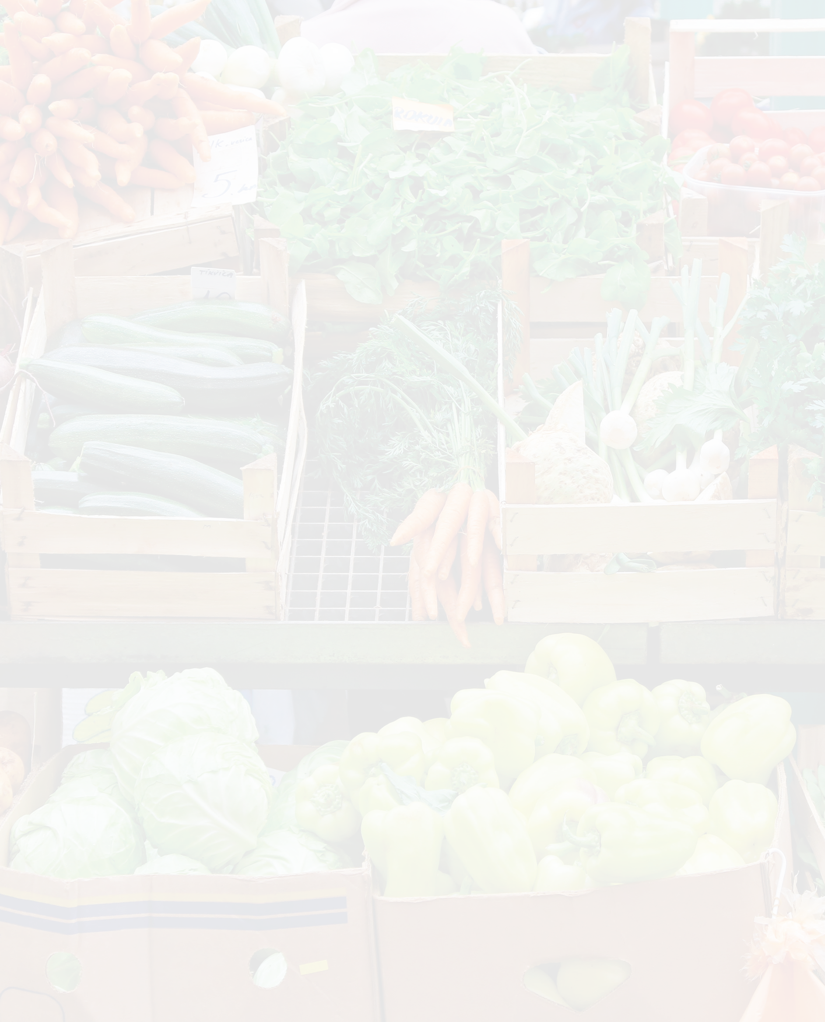

Zoo siab koom tes nog:



***“Kuv tau txaus siab xav kom txhua tus ua lub teeb cig pom kev tshiab thiab huab cua teeb tsa tau dawb.”***

**- Kathy, St. Paul tus tswv tsev**

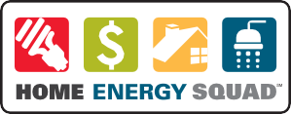

Hu rau 651-328-6220

Teem koj li ciaj nyoog tuaj saib hnub no!

Lub Tsev Hluav Taws Xob yog muab los ntawm CenterPoint Zog thiab Xcel Zog thiab xa los ntawm Lub Chaw rau Lub Zog thiab ib puag ncig (CEE), uas tsis yog hauv ib cheeb tsam.

Koj qhov kev mus saib Tse Hluav Taws Xob Dawb yog suav nrog pab pawg kws pab tswv yim txog hluav taws xob uas yuav tuaj rau hauv koj lub tsev, txheeb xyuas koj cov peev txheej txuag hluav taws xob, thiab muab cov kev pab cuam no (raws li koj lub tsev xav tau):

* Txhim kho cov ntaub ntawv pub dawb xws li LED, lub ntsuas cua sov, lub qhov rooj thiab nthab hle huab cua hle, tshaj qhov cub thiab cov kais dej zoo
* Kev ntsuam xyuas koj lub nthab thiab phab ntsa rwb thaiv tsev
* Kev ntsuam xyuas kev tiv thaiv kev nyab xeeb thiab ntsua xyuas carbon monoxide
* Daim ntawv ceeb toom

Thaum koj ua tiav qhov koj tuaj saib koj yuav tau txais $ 20 Kev lag luag cov khoom plig uas muaj peev xwm siv tau ntawm cov khw muag khoom koom nrog cov neeg ua liaj ua teb.

* Tsev Hluav Taws Xob muaj rau cov tswv tsev thiab tus xauj tsev hauv 1-4 chav tsev.

